Environment Variables Configuration File

What is an Environment Variables Configuration File?
# Source: AI Source: Provided by: [Data Path: Persons Table -> ID Column: 1, Name_En Column: Motasem Essam] -> From: [ChatGPT] on [1/26/2026]
An Environment Variables Configuration File is a file that stores environment-specific settings for an application in the form of key-value pairs.
- It allows an application to read configuration values without hardcoding them in the source code.
- These files are usually named .env in modern web development.
- They are often used for sensitive information (API keys, passwords, database credentials) and environment-specific settings (development, testing, production).

Key Points
# Source: AI Source: Provided by: [Data Path: Persons Table -> ID Column: 1, Name_En Column: Motasem Essam] -> From: [ChatGPT] on [1/26/2026]
- Purpose:
  - Separate configuration from code.
  - Easily switch settings between environments.
  - Keep secrets and sensitive info secure.
- Format:
  - Plain text
  - Simple KEY=VALUE pairs
  - No quotes needed for simple strings (optional for strings with spaces)
  - Comments allowed with #
- Typical Filename:
  - .env (dot env)
  - Sometimes .env.development, .env.production for multiple environments

Example of a .env File
# Source: AI Source: Provided by: [Data Path: Persons Table -> ID Column: 1, Name_En Column: Motasem Essam] -> From: [ChatGPT] on [1/26/2026]
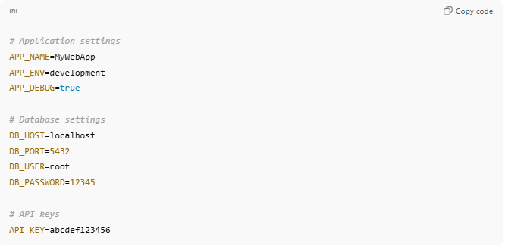
# Application settings
APP_NAME=MyWebApp
APP_ENV=development
APP_DEBUG=true

# Database settings
DB_HOST=localhost
DB_PORT=5432
DB_USER=root
DB_PASSWORD=12345

# API keys
API_KEY=abcdef123456

How It’s Used in Code
# Source: AI Source: Provided by: [Data Path: Persons Table -> ID Column: 1, Name_En Column: Motasem Essam] -> From: [ChatGPT] on [1/26/2026]
Node.js Example
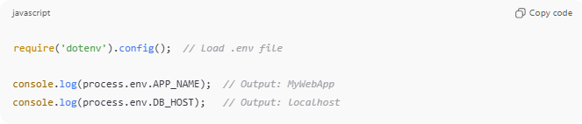
require('dotenv').config(); // Load .env file

console.log(process.env.APP_NAME); // Output: MyWebApp
console.log(process.env.DB_HOST); // Output: localhost
Python Example
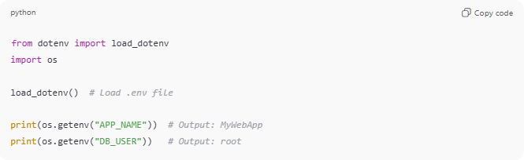
from dotenv import load_dotenv
import os

load_dotenv() # Load .env file

print(os.getenv("APP_NAME")) # Output: MyWebApp
print(os.getenv("DB_USER")) # Output: root

Advantages
# Source: AI Source: Provided by: [Data Path: Persons Table -> ID Column: 1, Name_En Column: Motasem Essam] -> From: [ChatGPT] on [1/26/2026]
- ✅ Keeps sensitive info out of the code repository
- ✅ Easy to switch between environments
- ✅ Makes applications portable across machines
- ✅ Simple, human-readable format

💡 Analogy:
# Source: AI Source: Provided by: [Data Path: Persons Table -> ID Column: 1, Name_En Column: Motasem Essam] -> From: [ChatGPT] on [1/26/2026]
Think of an Environment Variables Configuration File as a settings sheet for your app. Instead of hardcoding “this is the API key” in your program, you put it in a separate file that the program reads when it starts. This way, you can safely change secrets or settings without touching the code.

